**R Code for Examples in the book**

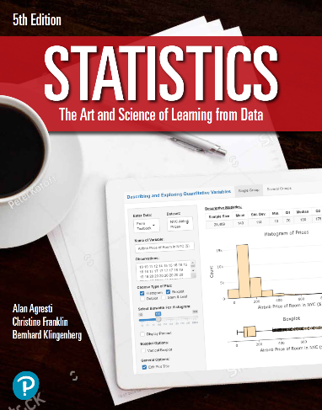

***“Statistics: The Art and Science of Learning from Data”***

**by Agresti, Franklin and Klingenberg, 5th edition**

**Chapter 10**

**Example 9: Cell Phone Use – Significance Test Comparing Two Means**

## Reading in the data

cellPhoneReactions <- read.csv(file='https://raw.githubusercontent.com/artofstat/data/master/Chapter10/cell_phone_reaction_times_long.csv')

## To subset data to make the two groups

cell <- subset(cellPhoneReactions, Group == 'Cell')  
control <- subset(cellPhoneReactions, Group == 'Control')

## To make a hypothesis test comparing the two means

t.test(cell$ReactionTime, control$ReactionTime)

##   
## Welch Two Sample t-test  
##   
## data: cell$ReactionTime and control$ReactionTime  
## t = 2.6307, df = 56.696, p-value = 0.01095  
## alternative hypothesis: true difference in means is not equal to 0  
## 95 percent confidence interval:  
## 12.31658 90.87092  
## sample estimates:  
## mean of x mean of y   
## 585.1875 533.5938